Force the Life Helper Service Worker Permissions to be rechallenged.

Select settings in Chrome and the “Privacy and security” entry.

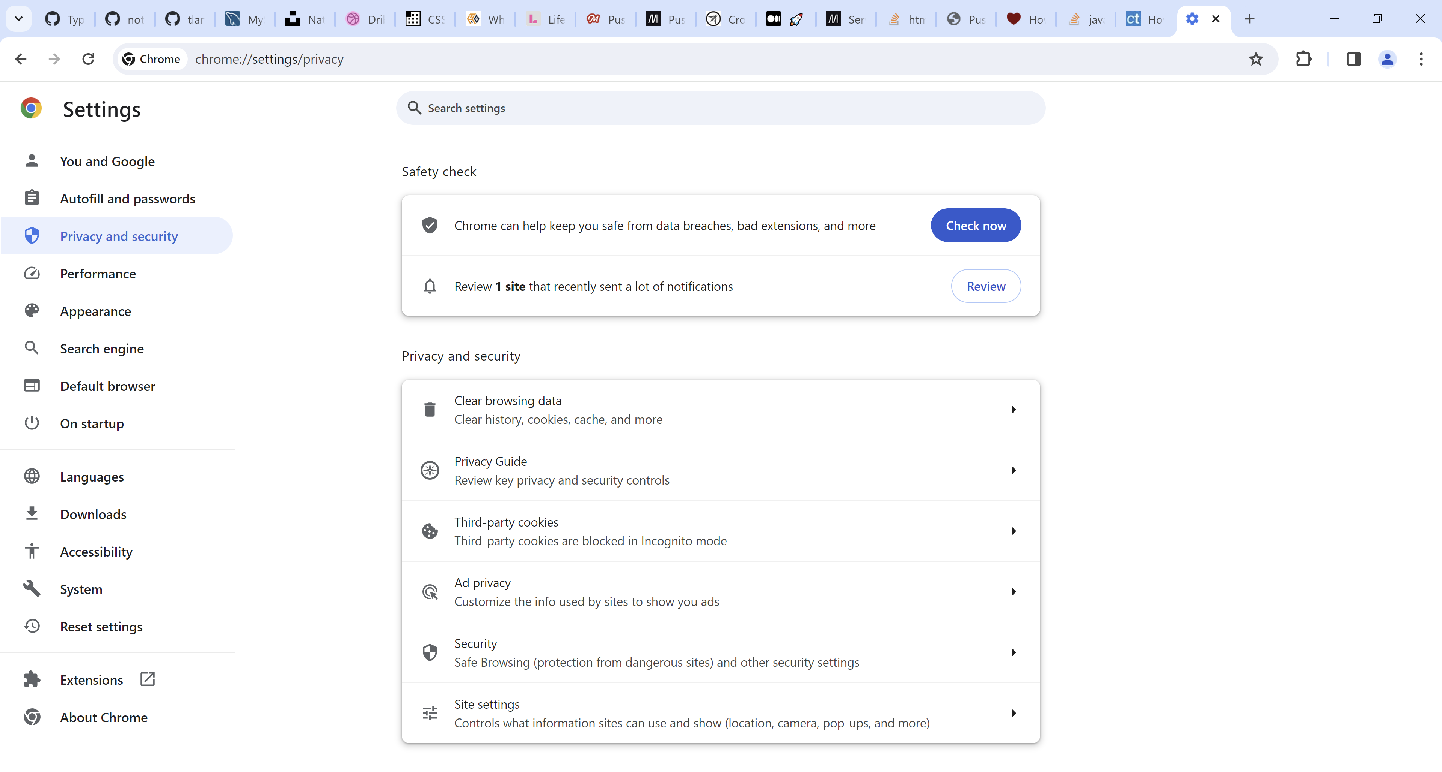

Select Site settings from the list. Then expand 127.0.0.1…

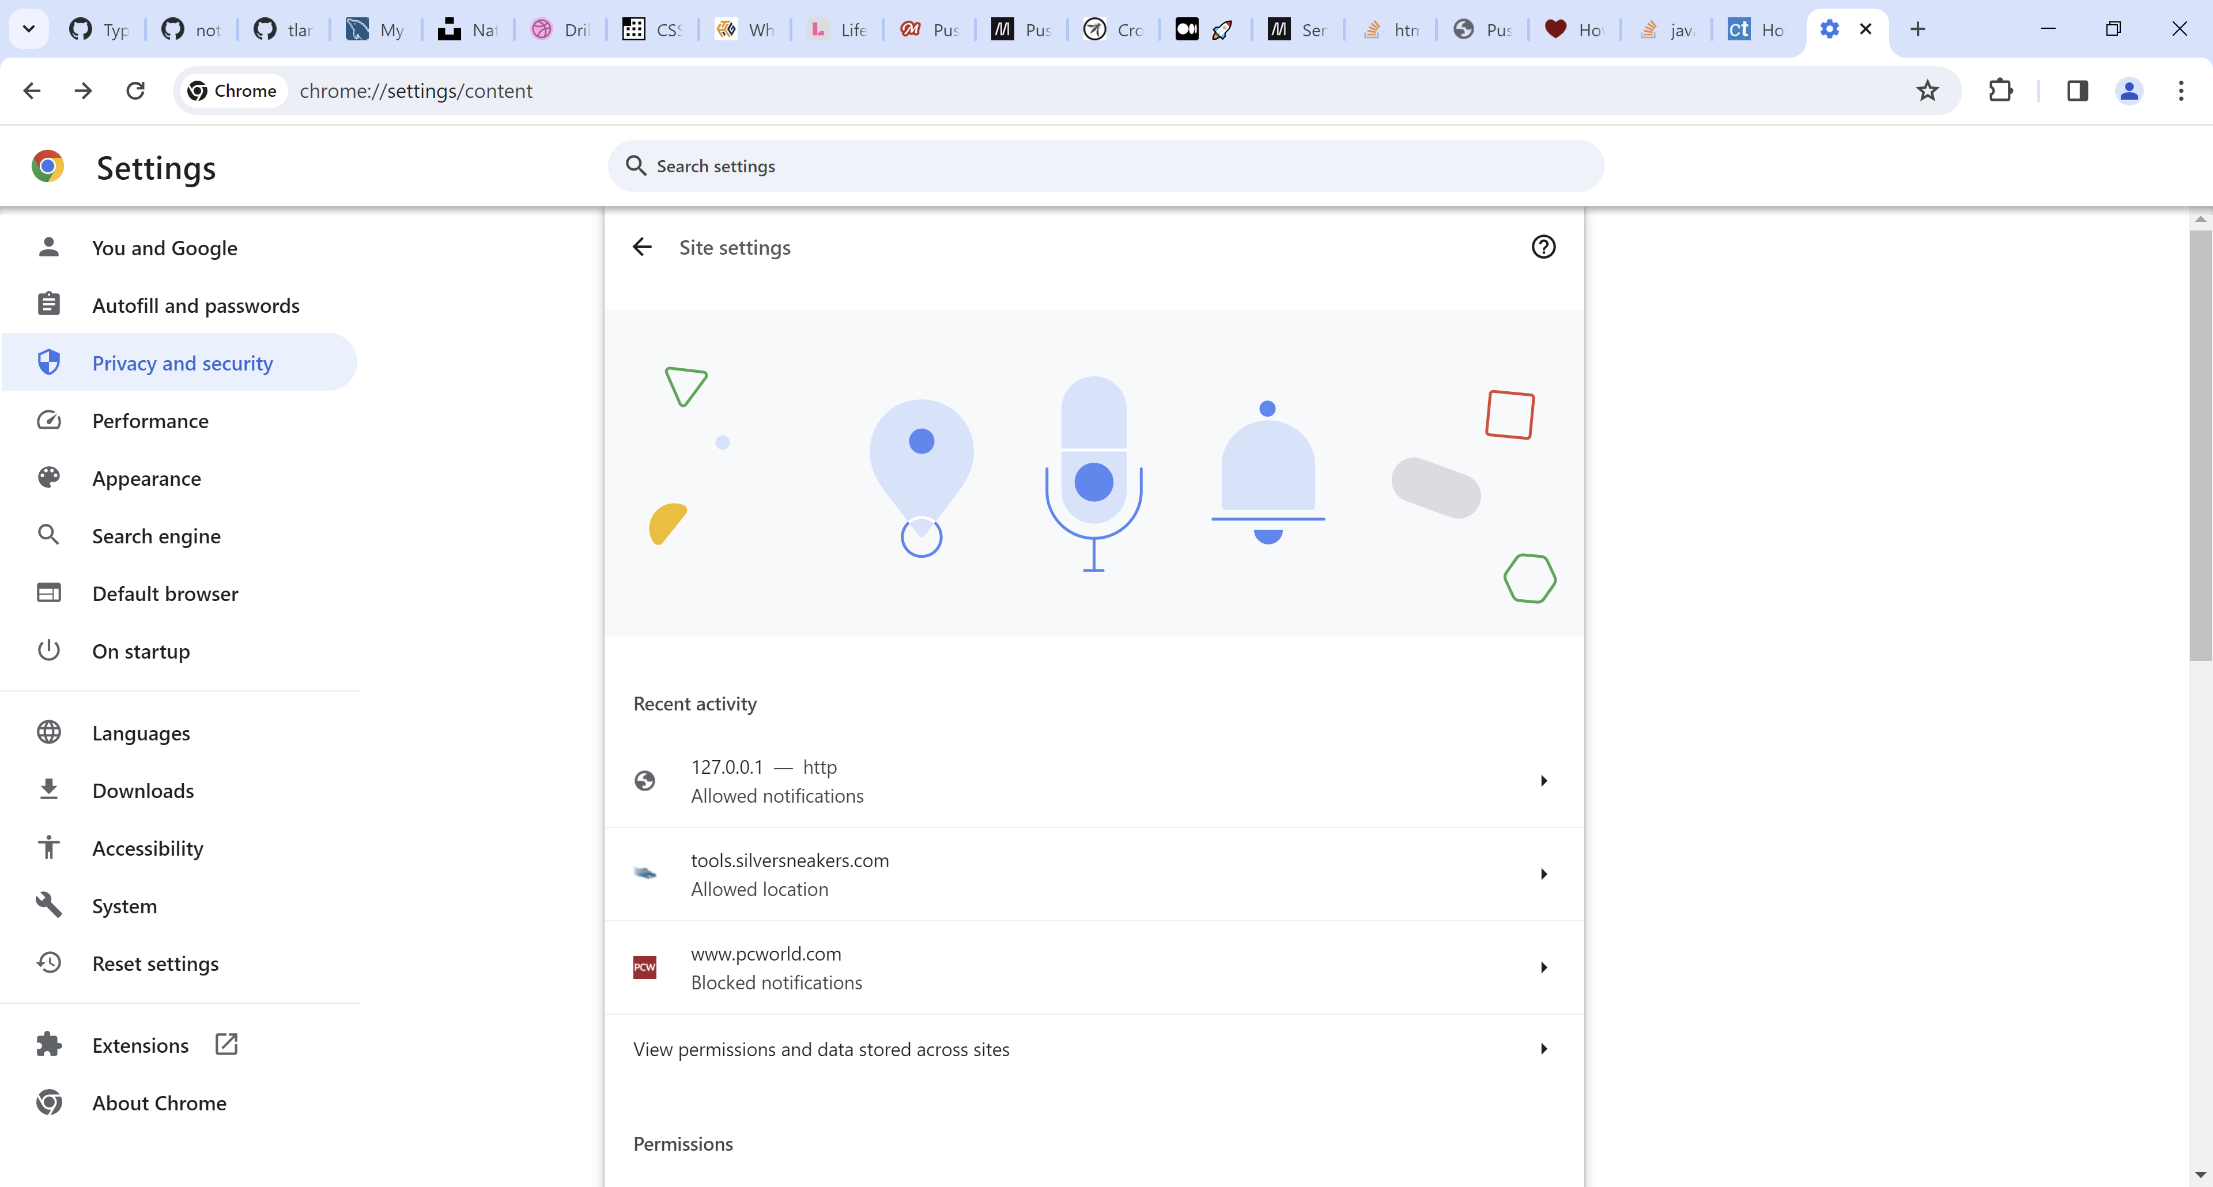

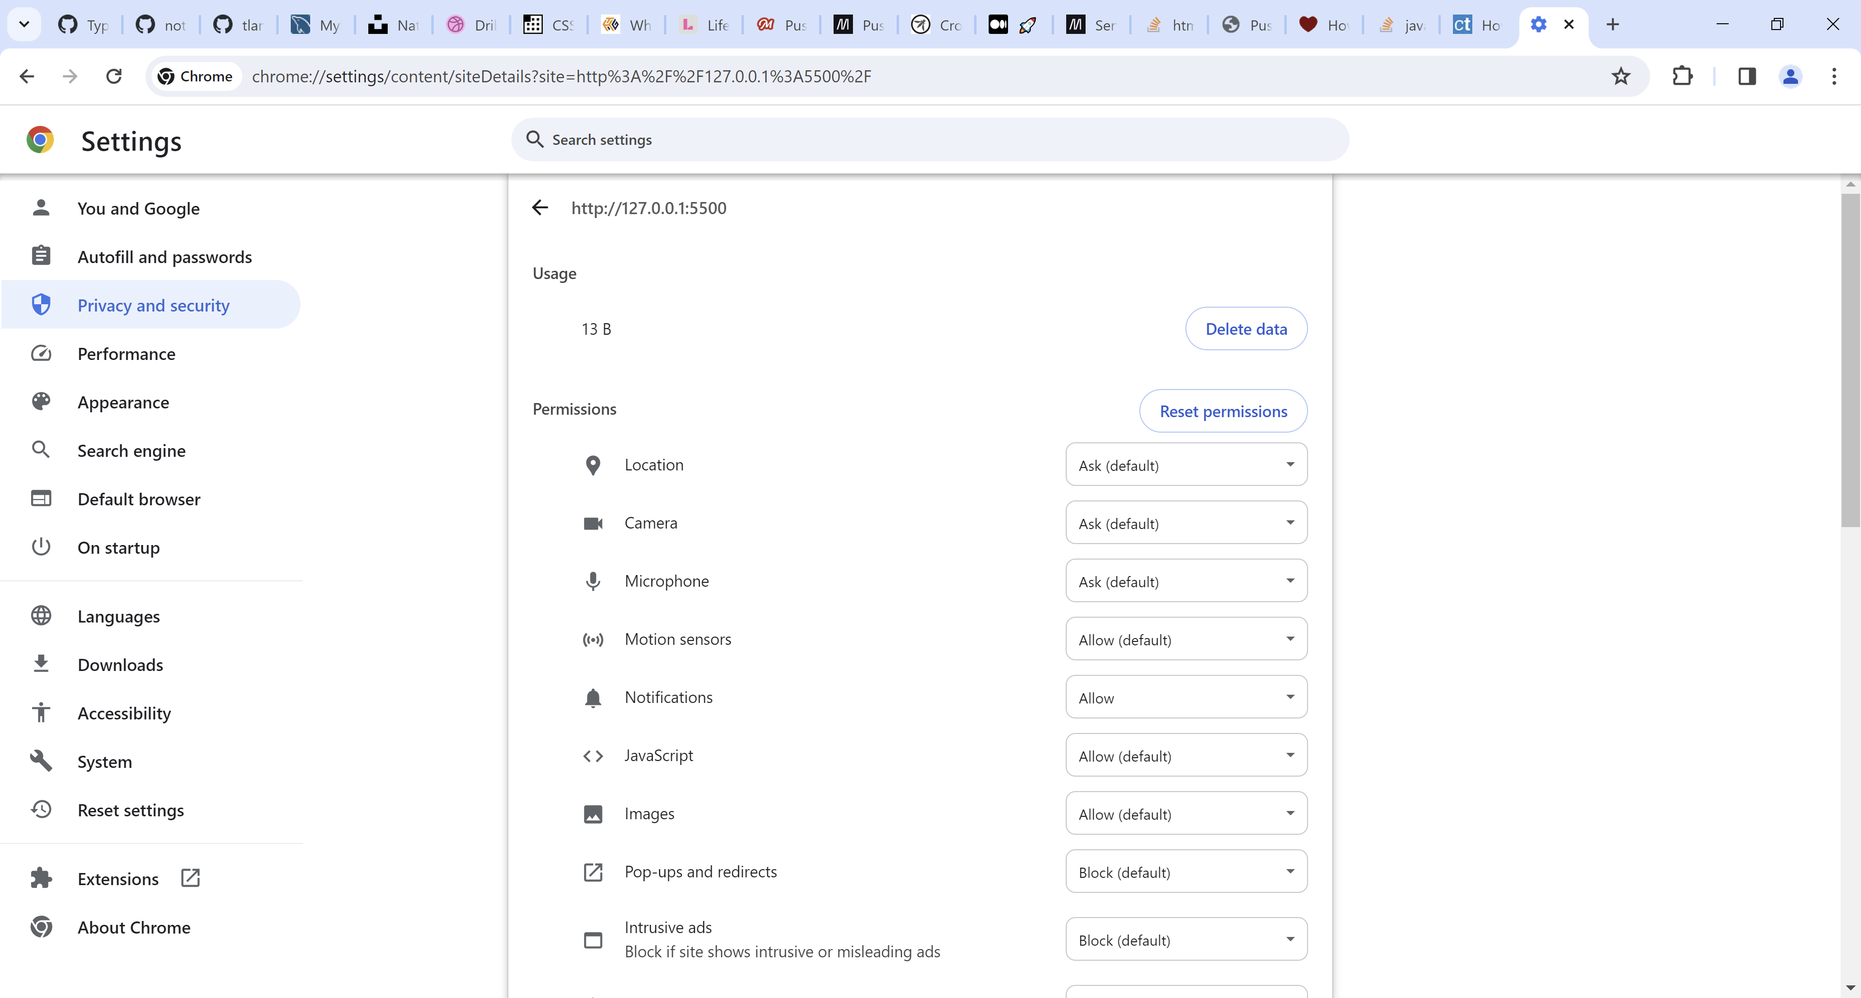

Change Notifications from Allow to Ask

